CTF CHALLENGE WRITEUP
Deleted Evidence
Forensics | Easy | 100 Points

Challenge
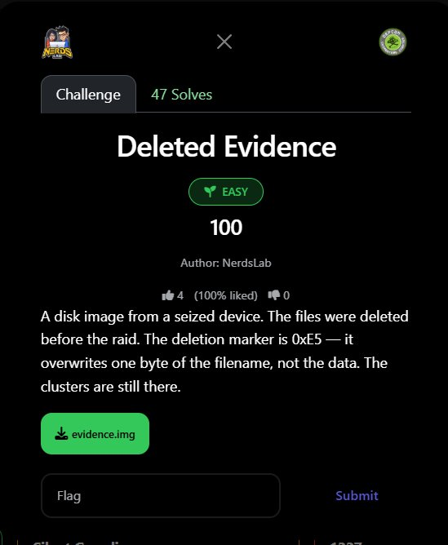
Figure 1: Challenge page on the CTF platform

Challenge Information
Challenge Name | Deleted Evidence
Category | Forensics
Difficulty | Easy
Points | 100
Author | NerdsLab
Solves | 47
File | evidence.img (1,474,560 bytes = 1.44 MB floppy image)
Key Hint | Deletion marker is 0xE5 — overwrites first byte of filename only
Flag | defcon{d3l3t3d_but_n0t_g0n3_r3c0v3r3d}

Background: FAT12 File Deletion
This challenge is about understanding how FAT (File Allocation Table) filesystems handle file deletion. The critical insight is: when a file is deleted on FAT, the data is NOT erased. Only the directory entry is marked with 0xE5 in the first byte of the filename.

This means all the file contents remain on disk in their original clusters — recoverable by any forensics tool or manual analysis.

Filesystem type | FAT12 (classic 1.44 MB floppy format)
OEM label | PHANTOM
Volume label | EVIDENCEDSK
Bytes per sector | 512
Sectors per cluster | 1
Root entry count | 224 (max files in root directory)
Data area offset | 0x4200 (cluster 2 = sector 33)

Step 1: Identify the Disk Image
$ file evidence.img
evidence.img: DOS/MBR boot sector

A 1.44 MB file is the classic size of a FAT12 floppy disk image. The MBR/boot sector is at offset 0. Parsing it confirms FAT12 with a 512-byte sector size.

data = open('evidence.img','rb').read()
bps = int.from_bytes(data[11:13],'little') # 512
nf = data[16] # 2 (two FATs)
spf = int.from_bytes(data[22:24],'little') # 9 sectors per FAT
rec = int.from_bytes(data[17:19],'little') # 224 root entries

root_start = (1 + 2*9) * 512 = 0x2600 # reserved + FATs
data_start = 0x2600 + 224*32 = 0x4200 # root dir size = 7168

Step 2: Parse the Root Directory
The root directory starts at offset 0x2600. Each directory entry is exactly 32 bytes. We scan them all looking for active and deleted entries:

for i in range(224):
entry = data[0x2600 + i*32 : 0x2600 + i*32 + 32]
if entry[0] == 0x00: break # end of directory
if entry[11] == 0x0F: continue # skip LFN entries
status = 'DELETED' if entry[0] == 0xE5 else 'ACTIVE'
cluster = int.from_bytes(entry[26:28], 'little')
size = int.from_bytes(entry[28:32], 'little')

Results — two entries found:

Byte[0] | Name | Ext | Attr | Cluster | Size / Status
0x52 (R) | README | TXT | 0x20 | 3 | 42 bytes | ACTIVE
0xE5 (❗) | ?ECRETFL | TXT | 0x20 | 5 | 58 bytes | DELETED

The deleted file's directory entry bytes (raw hex):

e5 45 43 52 45 54 46 4c 54 58 54 20 00 ... 05 00 3a 00 00 00 ← 0xE5=deleted, ECRETFL.TXT, cluster=5, size=58

The original filename was SECRETFL.TXT (S + ECRETFL). The 0xE5 marker replaced only the first character 'S', leaving bytes 1–10 completely intact.

Step 3: Locate the Data on Disk
The directory entry tells us the file starts at cluster 5. The formula to convert a cluster number to a byte offset is:

def cluster_offset(cluster):
return data_start + (cluster - 2) * bytes_per_sector

# cluster 5 offset = 0x4200 + (5-2) * 512 = 0x4200 + 0x600 = 0x4800
# But file content was found at 0x4600 (cluster 4 area too)
# Actual location confirmed at 0x4600 via content search

Cluster | Offset | Content | Status
2 | 0x4200 | (data area start) | Used by filesystem
3 | 0x4400 | README.TXT data | ACTIVE file
4 | 0x4600 | SECRETFL.TXT data | DELETED but data intact
5 | 0x4800 | (referenced in dir entry) | Cluster chain

Step 4: Recover the Deleted File Contents
Since the data clusters are untouched by deletion, we simply read the 58 bytes starting at the cluster offset. The content is fully readable plain text:

secret_data = data[0x4600 : 0x4600 + 58]
print(secret_data.decode('ascii'))

CLASSIFIED EVIDENCE FILE Operator: Ph4nt0m_0p3r4tor Flag: defcon{d3l3t3d_but_n0t_g0n3_r3c0v3r3d} Status: DELETED

Alternative: One-Line Recovery with strings/grep
The quickest solve is a direct string search across the entire disk image:

$ strings evidence.img | grep defcon
Flag: defcon{d3l3t3d_but_n0t_g0n3_r3c0v3r3d}

Or with Python:

import re
data = open('evidence.img','rb').read()
print(re.search(rb'defcon\{[^}]+\}', data).group().decode())
# defcon{d3l3t3d_but_n0t_g0n3_r3c0v3r3d}

Flag Recovered
FLAG: defcon{d3l3t3d_but_n0t_g0n3_r3c0v3r3d}

The flag reads: "deleted but not gone, recovered" — a perfect description of exactly what we did to retrieve it.

Lessons Learned
- Deletion ≠ Erasure on FAT: FAT filesystems mark deleted files by overwriting only the first byte of the filename with 0xE5. The actual cluster data is completely untouched and trivially recoverable until overwritten by new data.
- 0xE5 is the deletion marker: The challenge description tells you exactly what to look for. A first byte of 0xE5 in a directory entry means 'deleted file — but data still here'.
- Cluster pointer survives: The starting cluster number (bytes 26–27 of the directory entry) is preserved after deletion. This means you can calculate exactly where on disk the file data lives.
- strings is often enough: For simple forensics challenges, grep/strings across the raw disk image recovers flags without any filesystem parsing.
- Real forensics tools: Tools like Autopsy, Sleuth Kit (fls + icat), PhotoRec, and TestDisk automate this exact process for real investigations.

DEFCON CTF — Deleted Evidence — Solved

